**IBM BLUEMIX**

**Bluemix** is an open standards, cloud platform for building, running, and managing apps and services.

IBM Bluemix is an open-standards, cloud platform for building, running, and managing applications. With Bluemix, developers can focus on building excellent user experiences with flexible compute options, choice of DevOps tooling, and a powerful set of IBM and third-party APIs and services.

Build & Run Apps

Use powerful, open-source technologies to power your apps. Let Bluemix handle the rest.

### Instant Runtimes

App-centric runtime environments based on Cloud Foundry.

### IBM Containers

Portability and consistency without having to manage an OS.

### Virtual Machines

The most control and flexibility with your apps and middleware.

Bluemix provides the following features:

* A range of services that enable you to build and extend web and mobile apps fast.
* Processing power for you to deliver application changes continuously.
* Fit-for-purpose programming models and services.
* Manageability of services and apps.
* Optimized and elastic workloads.
* Continuous availability.

1. You can upload your web app to Bluemix and indicate how many instances that you want running
2. You can develop mobile apps in iOS, Android, and HTML with JavaScript. For web apps, you can use languages such as Ruby, PHP, Java™, Go, and Python. You can also migrate existing apps to Bluemix and use the runtimes that Bluemix provides to run your apps.
3. you don't have to worry about the operating system and infrastructure layers when running apps on Bluemix

## Bluemix architecture

With Bluemix, you can access the public Bluemix platform, set up a dedicated Bluemix platform, or use both.

### Bluemix Public

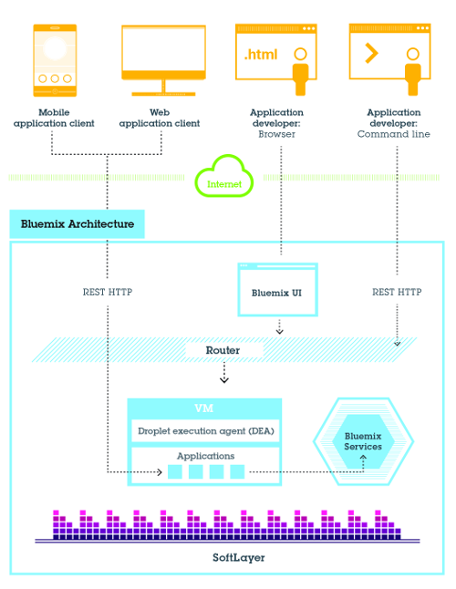

### Bluemix Dedicated

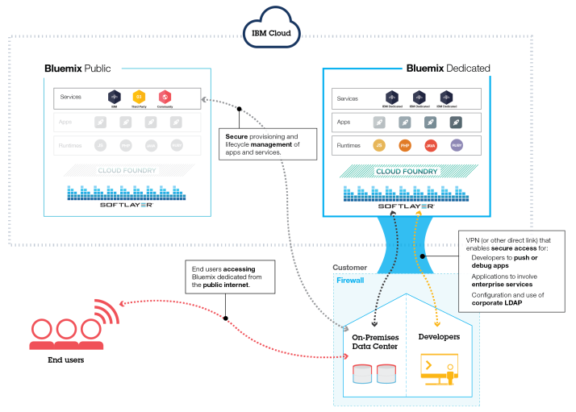

### Bluemix Local

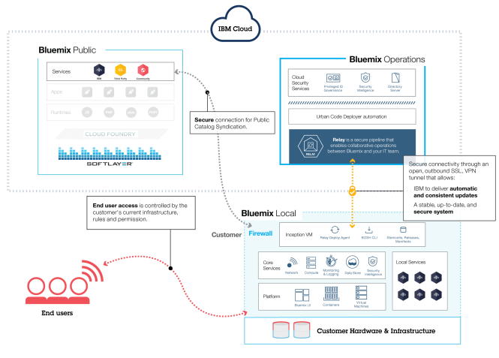

### How Bluemix works

When you deploy an app to Bluemix, you must configure Bluemix with enough information to support the app.

* For a mobile app, Bluemix contains an artifact that represents the mobile app's back end, such as the services that are used by the mobile app to communicate with a server.
* For a web app, you must ensure that information about the proper runtime and framework is communicated to Bluemix, so that it can set up the proper execution environment to run the app.
* When you create an app and deploy it to Bluemix, the Bluemix environment determines an appropriate virtual machine (VM) to which the app or artifacts that the app represents is sent.
* After a VM is chosen, an application manager on each VM installs the proper framework and runtime for the app. Then the app can be deployed into that framework. When the deployment is completed, the application artifacts are started.
* the following figure shows the structure of a VM, also known as Droplet execution agent (DEA), that has multiple apps deployed to it: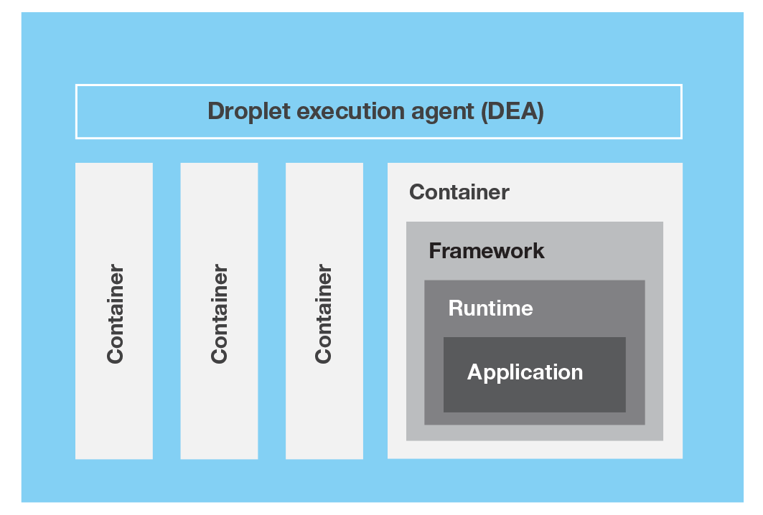
* You can have one or more instances running for your app. When you have multiple instances for one app, the app is uploaded only once. However, Bluemix deploys the number of instances of the app requested, and distributes them across as many VMs as possible.
* IBM Containers are used to run Docker containers in a hosted cloud environment. Docker adds an engine that deploys an app to the virtual environment that you use for running your containers. Docker also provides an environment that you can use to run your code. When you're ready, it provides the means by which you can transfer the code from your development environment, to your test environment, and then to your production environment.
* A service is a cloud extension that is hosted by Bluemix. The service provides functionality that is ready-for-use by the app's running code. The predefined services that are provided by Bluemix include database, messaging, push notifications for mobile apps, and elastic caching for web apps.
* A starter is a template that includes predefined services and app code that is configured with a particular buildpack. There are two types of starters: boilerplates and runtimes. A starter might be app code that is written in a specific programming language, or a combination of app code and a set of services.
* a boilerplate contains an app and its associated runtime environment and predefined services for a particular domain.
* A runtime is the set of resources that is used to run an appA runtime is the set of resources that is used to run an appA buildpack is a collection of scripts that prepare your code for execution on the target PaaS. A buildpack gathers the runtime and framework dependencies of an app. Then, it packages them with the app into a droplet that can be deployed to the cloud.